Understand Linked Lists

Types of Linked Lists:

* Singly Linked List
  + Each node points to the next node.
  + One-way traversal.
  + Simple and memory-efficient.
* Doubly Linked List
  + Each node points to both next and previous nodes.
  + Allows two-way traversal, easier deletion from both ends.

Analysis:

|  |  |  |
| --- | --- | --- |
| Operation | Time Complexity | Explanation |
| Add | O(n) | Traverses to the end to add |
| Search | O(n) | Linear scan to match task ID |
| Traverse | O(n) | Visit every node |
| Delete | O(n) | Find and unlink the node |

Advantages of Linked Lists over Arrays:

|  |  |  |
| --- | --- | --- |
| Feature | Arrays | Linked Lists |
| Size | Fixed | Dynamic |
| Insert/Delete | Complex (O(n)) | Efficient (O(1) if position known) |
| Memory | May waste space | Allocates as needed |
| Random Access | O(1) using index | O(n) (no index) |

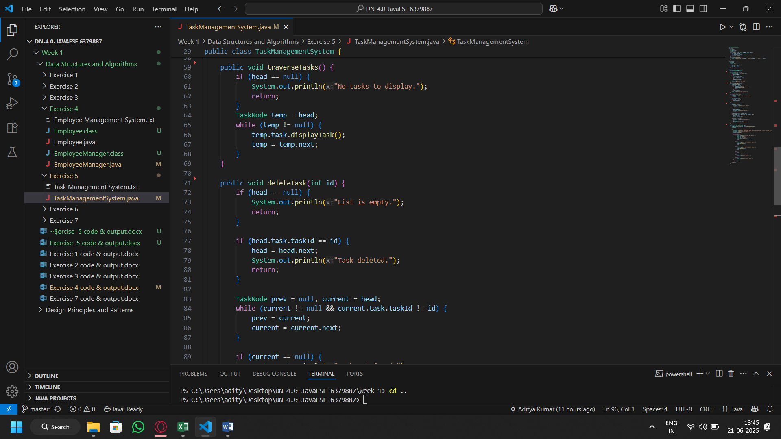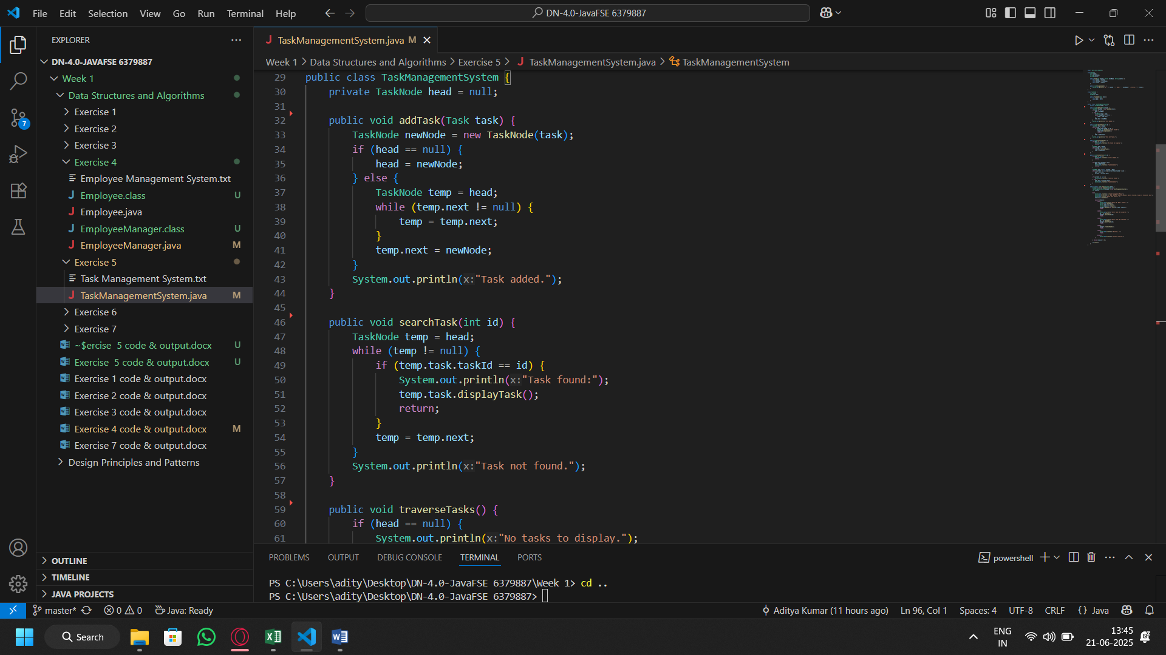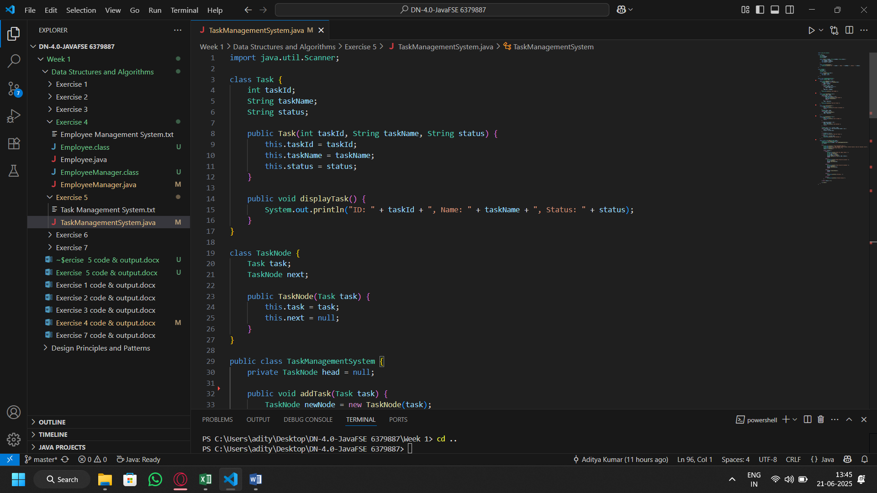Code:

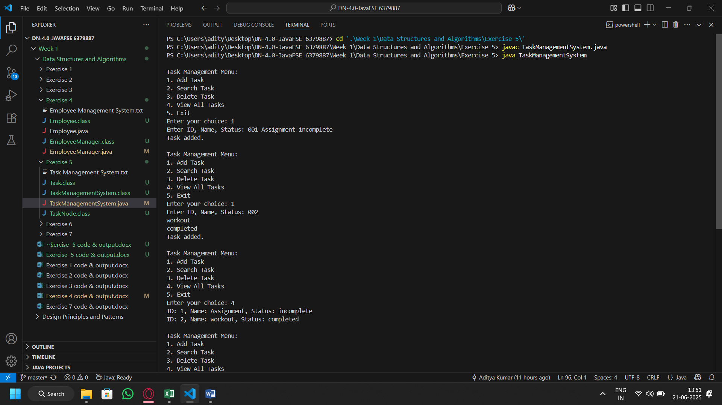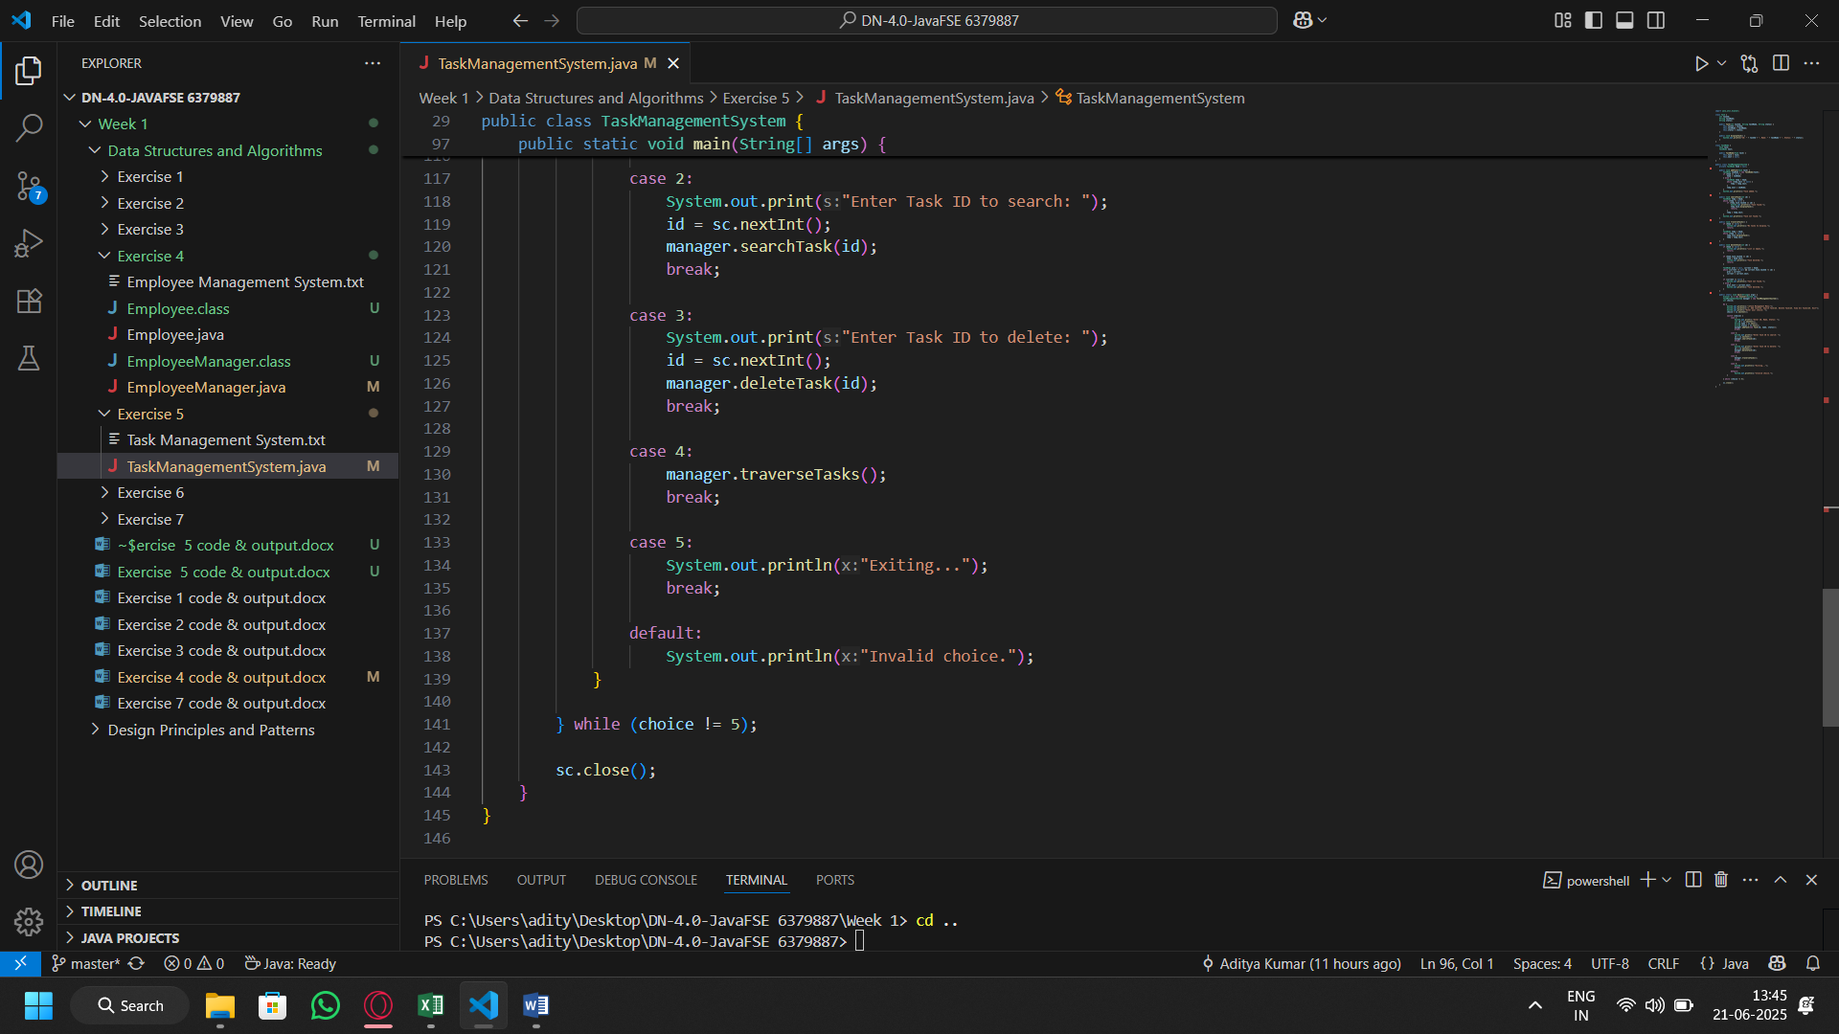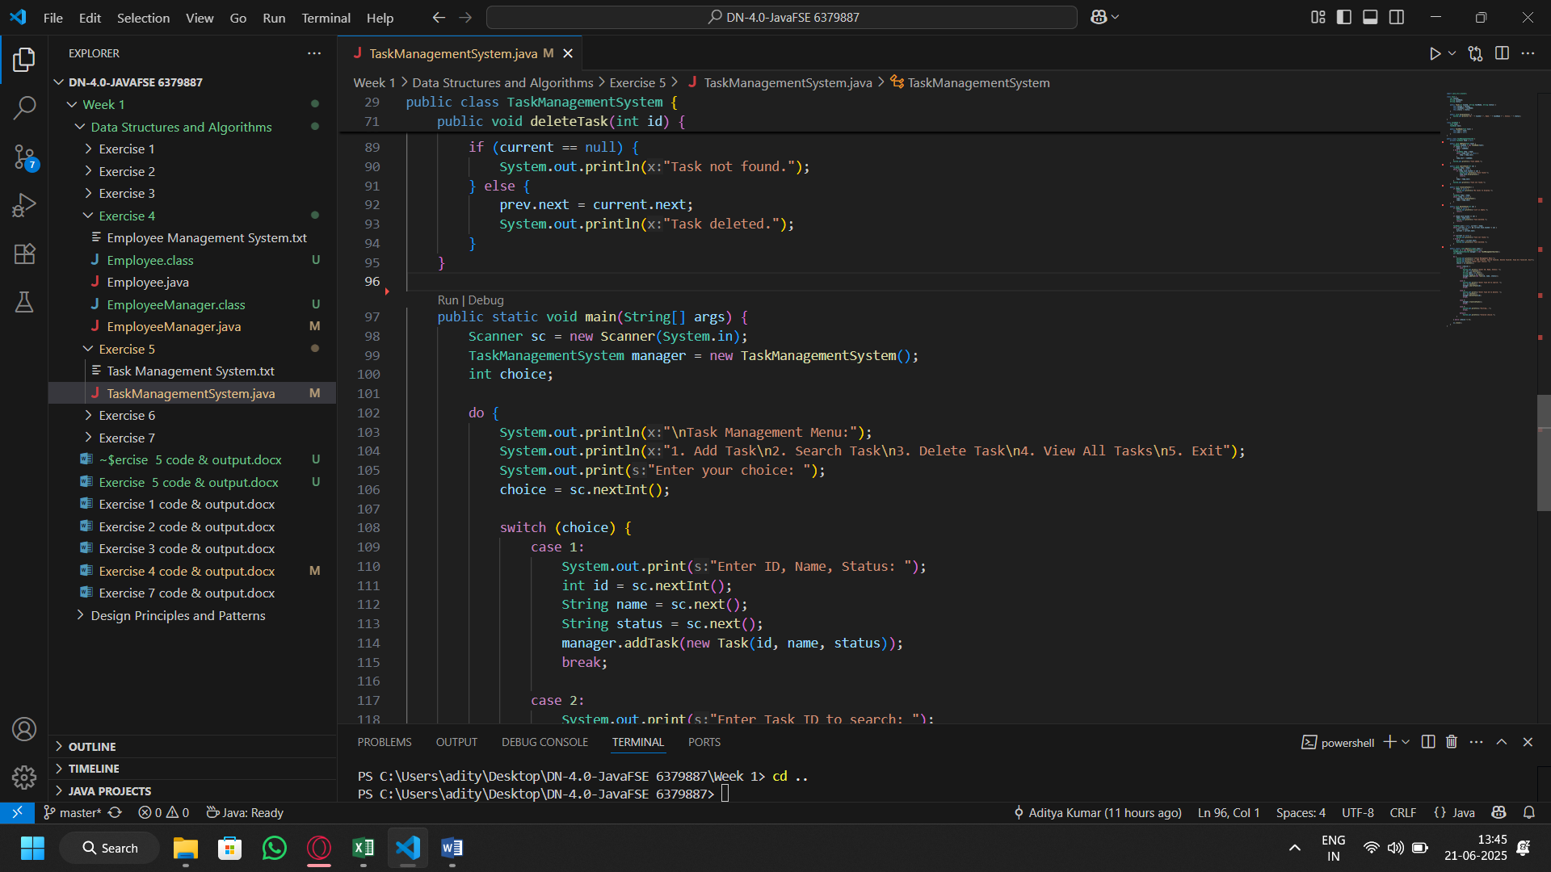Output: